Mathematical Section

If sec θ sin θ = 0, cos θ is equal to?

(a) 0
(b) 1/2
(c) 1
(d) -1/2

If sin θ + cos θ = a, tan θ + cot θ = b, then?

(a) 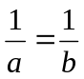
(b) 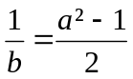
(c) 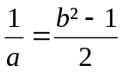
(d) a + b = 0

The angle of elevation of the sun, when the length of the shadow of a pole is  times the height of the pole, is?

(a) 30°
(b) 45°
(c) 60°
(d) 75°
sec² θ = 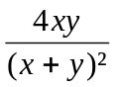 is true,

(a) When x = y
(b) When x < y
(c) When x > y
(d) For every value of x and y

If tan θ = 2 - , then tan (90° - θ) is equal to?

(a) 2 +
(b) 2 -
(c) 2 - 
(d) 3 -

sin θ cos θ would have maximum value when θ is equal to?

(a) 45°
(b) 60°
(c) 90°
(d) None of these

The equation 6 sin²x – 5 sin x + 1 = 0 is satisfied by?

(a) x = 90°
(b) x = 60°
(c) x = 45°
(d) x = 30°

F (x) = (sin x – cos x)². Find the maximum value of F (x)?

(a) 0
(b) 1
(c) 2
(d) Infinite

If tan θ + cot θ = 2, then tan²θ + cot²θ is equal to?

(a) 2
(b) 6
(c) 3
(d) 10

If bases of two similar triangles are in the ratio of 2:3, their areas would be in the ratio of?

(a) 2: 7
(b) 4: 9
(c) 9: 4
(d) 9: 7

Three straight lines OA, OB and OC have been drawn from point O. OP is so drawn such that it bisects ∠BOA and OQ is so drawn that it bisects ∠AO(C) Then ∠POQ is equal to?

(a) 2∠BOC
(b) ∠BOC
(c) ∠BOC
(d) ∠BOC

The parallel sides of a trapezium are a and b in length. The length of the line joining the middle points of its oblique sides is?

(a) 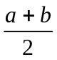
(b) 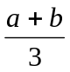
(c) (a + b)²
(d) 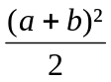

Two circles of radii x and y touch each other externally. If AB is the common tangent, then AB² is given by?

(a) (x + y)²
(b) (x – y)²
(c) x² + y²
(d) 4xy

In the figure given below, PS is equal to?
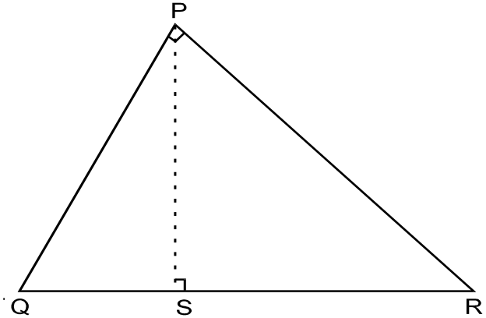

(a) 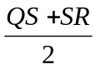
(b) 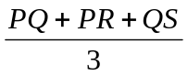
(c) 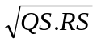
(d) 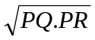

In 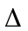PQS, R is a point on line PS such that PR = QR and QS = RS. If ∠RSQ = 120°, then ∠QPR is equal to?

(a) 20°
(b) 15°
(c) 22°
(d) 30°

In the figure given below AB = 10 cm, PB = 4 cm, PD = 8 cm. What is the measure of PC?
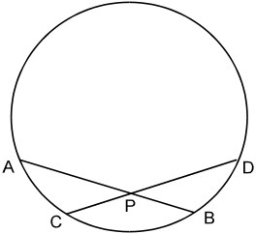

(a) 3 cm
(b) 4 cm
(c) 5 cm
(d) 3.2 cm

The length of the tangent to a circle with radius 5 cm, drawn from a point 13 cms from the centre of the circle, is?

(a) 12 cm
(b) 13 cm
(c) 10 cm
(d) 9 cm
Four points A, B, C and D lie on the circumference of a circle such that they form a square. If the area of the circle is 100π³, then the area of the square ABCD is?

(a) 200π
(b) 200π²
(c) 200π³
(d) 100π²

In any triangle, the centroid divides the medians in the ratio?

(a) 1: 1
(b) 2: 1
(c) 3: 1
(d) 3: 2

A ball was floating in a lake when the lake froze. The ball was removed (without breaking the ice), leaving a hole 24 cm across at the top and 8 cm deep. What was the radius of the ball (in centimeters)?

(a) 8
(b) 12
(c) 13
(d) 8

The ratio of the areas of the incircle and the circumcircle of a square is?

(a) 1:
(b) 1:
(c) 1: 4
(d) 1: 2

In a four-sided polygon, the longer diagonal is 16 cm. The perpendiculars from the opposite vertices fall upon the longer diagonal are 10 cm and 12 cm in length. The area of the field is?

(a) 140 cm²
(b) 352 cm²
(c) 176 cm²
(d) 280 cm²

Ratio of the whole surface of the sphere to the curved surface of the cylinder when sphere just fits into the cylinder?

(a) 1: 1
(b) 1: 2
(c) 2: 1
(d) 3: 2

If the diagonal of a square is halved, then the ratio of its area to that of the original one is?

(a) 1/4
(b) 3/4
(c) 1/6
(d) 1/

The circumferences of two circles are p₁ and p₂. The circumference of a third circle, whose area is equal to the sum of the areas of first two circles is?

(a) 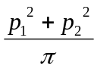
(b) 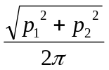
(c) 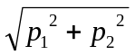
(d) 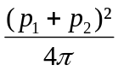

Three equal cubes are placed side by side in a row. The ratio of the surface area of the new cuboid so formed to the sum of the surface areas of 3 cubes is?

(a) 7: 8
(b) 7: 9
(c) 5: 9
(d) 3: 8

In the following figure, every semicircle is of radius 2 cm. Find the area?
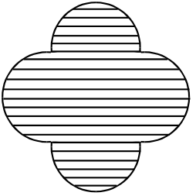

(a) 25.12 cm²
(b) 41.12 cm²
(c) 8 cm²
(d) 16 cm²

A dishonest dealer professes to sell his goods at CP but he uses a weight of 960 gms for the kg weight. Find his gain percent?

(a) 4%
(b) 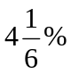
(c) 40%
(d) 10%

In an examination 60% candidates passed in English, 52% in Maths and 32% failed in both. If 220 candidates passed in both, then total candidates were?

(a) 200
(b) 300
(c) 400
(d) 500

What is the least number, which when divided by 8, 10, 15, 25 or 36, leaves remainder 3 in each case?

(a) 1805
(b) 1803
(c) 1797
(d) 1795

In a right-angled triangle with sides p and q and hypotenuse r, the altitude drawn on the hypotenuse is?

(a) 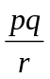
(b) 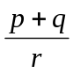
(c) 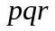
(d) 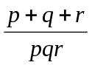

Two trains travel in the same direction at 56 km per hour and 29 km per hour. The faster train passes by a man in the slower train in 16 seconds. Find the length of the faster train?

(a) 200 m
(b) 240 m
(c) 120 m
(d) 112 m

In a class of 87 teachers, 47 know Hindi, 35 know Telugu and 23 know both. The number of teachers, who know neither Hindi nor Telugu is?

(a) 24
(b) 28
(c) 36
(d) 25

If (x, y) is a solution to the system xy = 6 and x²y + xy² + x + y = 63, find x² + y²?

(a) 13
(b) 1173/32
(c) 81
(d) 69

In the table shown, the formula relating x and y is

X | 1 | 2 | 3 | 4 | 5
Y | 3 | 7 | 13 | 21 | 31

(a) y = 4x – 1
(b) y = x³ - x² + x + 2
(c) y = x² + x +1
(d) y = (x² + x + 1) (x – 1)

Ten years ago, the average age of a family of four members was 25 years. Two children having been born, the average age of the family is the same today. What is the age of the youngest child if they differ in age by 2 years?

(a) 3 years
(b) 2 years
(c) 4 years
(d) 8 years

Find the solution of the equation log₇ log₅ 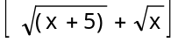 = 0
(a) x = 3
(b) x = 2
(c) x = 4
(d) x = 6

The total number of numbers from 1000 to 9999 (both inclusive) that do not have four different digits is?

(a) 1236
(b) 2325
(c) 3574
(d) 4464

The value of x² - 6x + 13 can never be less than?

(a) 4
(b) 5
(c) 4.5
(d) 7

If a^{x} = b^{y} = c^{z} and b² = ac then y is equal to?

(a) 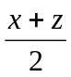
(b) 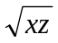
(c) 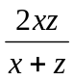
(d) 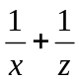

The square root of (x² + 4x + 4) (x² + 6x + 9) is?

(a) x² + 5x + 6
(b) x² + 6x + 5
(c) x² - 5x + 6
(d) x² + 5x – 6

p varies inversely as q + 3. If p = 1 when q = 3, what is the value of p when q = 1?

(a) 1/3
(b) 2/3
(c) 3/2
(d) None of these

The combined mean of two groups A and B is 28. The mean of group A is 30 when there are 25 students in it. If there were 20 students in group B, what would be the mean of group B?

(a) 30.5
(b) 27.5
(c) 31.5
(d) 25.5

The average of 15 numbers is 18. The average of first eight numbers is 19 and that of last 8 numbers is 17. What is the eighth number?

(a) 17
(b) 18
(c) 21
(d) 19

In the given figure O is the centre of the circle inscribed in a square ABCD. If MA = 5cm then AB is
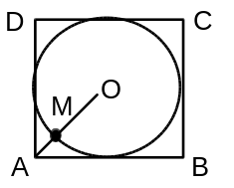

(a) 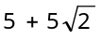
(b) 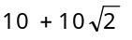
(c) 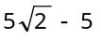
(d) 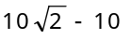

In the figure given below the sum of the angles at the vertices is equal to?
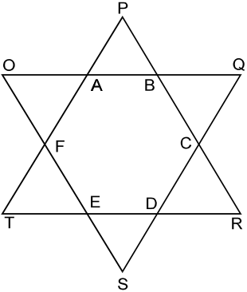

(a) 2 π
(b) 3 π
(c) 4 π
(d) 5 π

In the adjoining figure, ∠PQR is equal to?
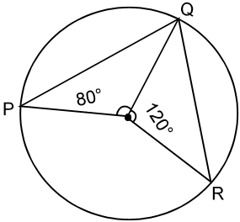

(a) 60°
(b) 80°
(c) 100°
(d) 120°

ABC is an equilateral triangle. O is the point of intersection of its medians. If AB = 6 cm, then what is the value of OB?

(a) 3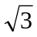
(b) 2
(c)
(d) 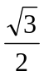

ABCD is a square. E is the mid-point of BC and F is the mid-point of CD. The ratio of the area of AEF to the area of square ABCD is?

(a) 8: 3
(b) 3: 8
(c) 3: 7
(d) 7: 3

If in the figure given below, PS = 9 cm, PR = 4 cm, then what is the measure of PT?
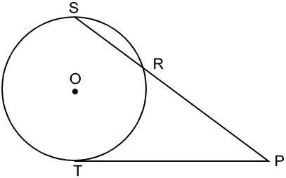

(a) 8 cm
(b) 6 cm
(c) 9 cm
(d) 12 cm

P and Q are the mid-points of sides AB and BC, respectively of ABC. The triangle is right angled at B. Which one of the following is correct?

(a) AQ² + CP² = 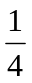AC²
(b) AQ² + CP² = AC²
(c) AQ² + CP² = 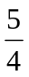 AC²
(d) AQ² + CP² = 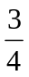AC²

